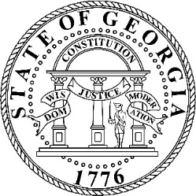

Georgians for Refuge, Action, Compassion & Education Commission

April 4, 2022

PUBLIC NOTICE
OPEN MEETING

Pursuant to the terms of O.C.G.A. § 50-14-1, notice is hereby given to the public that a meeting of the GRACE Commission is scheduled for Tuesday, April 11, 2023, at 11:30 a.m. The meeting will be held at the Governor’s Mansion, 391 West Paces Ferry Road NW, Atlanta, Georgia 30305.

Members of the public may join the meeting virtually via a livestream that will be available here: https://www.facebook.com/MartyKempGA/.

