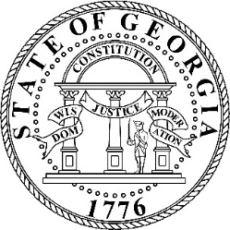

Georgians for Refuge, Action, Compassion & Education Commission

March 13, 2024

PUBLIC NOTICE
OPEN MEETING

Pursuant to the terms of O.C.G.A. § 50-14-1, notice is hereby given to the public that a meeting of the GRACE Commission is scheduled for Wednesday, March 20th, 2024, at 10:00 a.m. The meeting will be held at the Signia by Hilton Atlanta Georgia World Congress Center Hotel, 159 Northside Drive NW, Atlanta, Georgia 30313 in Magnificent 3 Room.

Members of the public may join the meeting virtually via a livestream that will be available here: https://www.facebook.com/MartyKempGA/.

